**Eraj Shakoor**

**33131**

**BSCS**

**Operating System lab**

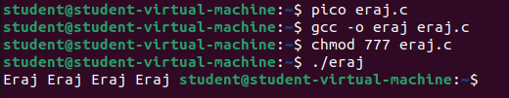**AND Operator**

**OR operator**

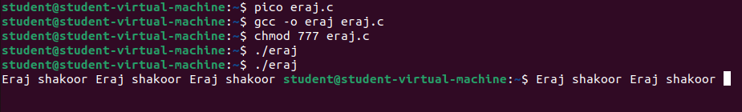

**System (ls)**

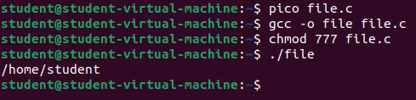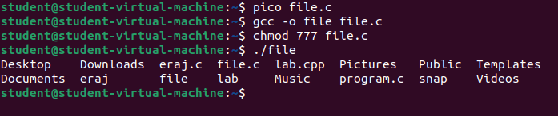

**System (pwd)**

**If-else**

